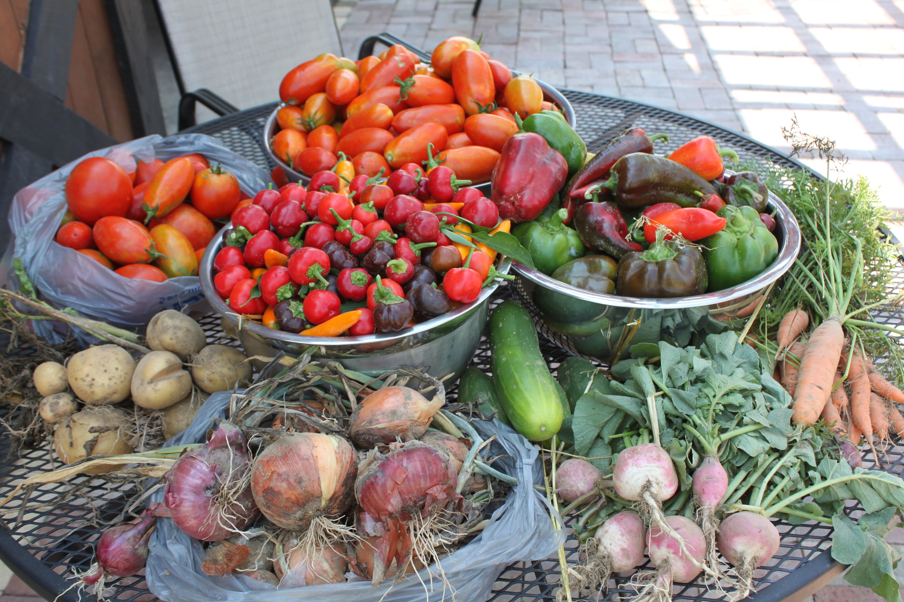  11 march 2017  a WORKDAY AT THE GARDEN  Meet us at The Garden for a time of cleaning the land to prepare it for planting. Bring along your rakes, string trimmers, pruning tools, etc. if you have them. We hope to complete many of the following items:  - Cut down trees  - Dig up bushes  - Move junk pile  - Clear off land  - Move old trailer  - Till small patch  - Clear bank | Garden Workday  ────  Prepare, plant, tend, harvest  ────  Laugh, work, and fellowship  ────  Put God’s love into action by serving others  ────  “If you open your heart to the hungry... The LORD will guide you continually... You will be like a watered garden, like a spring of water that won’t run dry.” (Isaiah 58:10–11 CEB)  wEAVER UNITED mETHODIST  545 Anniston ST.  WEAVER, AL 36277  256-820-2440  www.weaverfirstumc.org  11 March 17; 12 – 4 p.m.

